Kirtland’s Warbler Business Plan

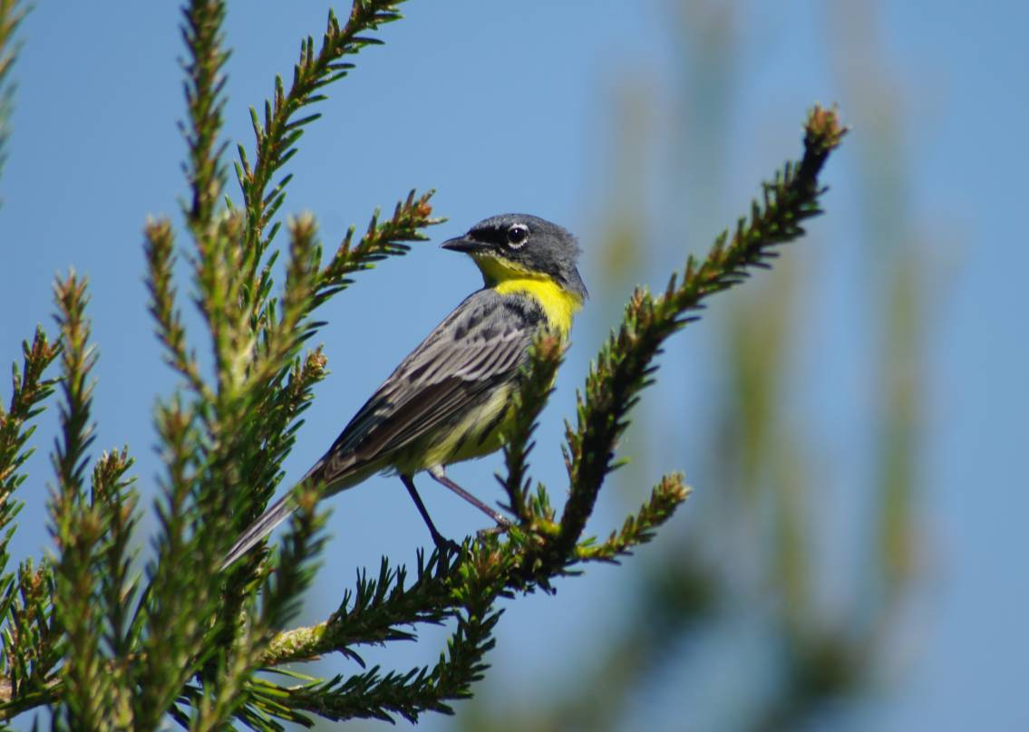

The Kirtland’s Warbler Conservation Team
April 15, 2019

Table of Contents
Executive Summary 3
Conservation Need 4
Implementation Plan 6
Conservation Outcomes 12
Funding Needs/Budget 12
Evaluation and Monitoring 13
Partner Organizations 14

Executive Summary

The endangered Kirtland’s Warbler, which breeds in young jack pine stands almost exclusively in northern Michigan and winters almost exclusively in dense scrub in The Bahamas, is dependent on ongoing management to survive. Intensive forest management and removal of a nest parasite, the Brown-headed Cowbird, has resulted in recovery from the edge of extinction. The Kirtland’s Warbler population has grown from an estimate of 167 pairs in the 1980s to nearly 2,300 pairs in 2015. The Kirtland’s Warbler’s recovery is one of the most celebrated conservation success stories in North America, and people from around the world visit the Michigan breeding grounds to glimpse this iconic species. Even though it remains one of the rarest migratory songbirds in North America, the species, which was probably always rare, is now being considered for removal from Endangered Species Act protections, as its population has exceeded the recovery goal of 1,000 pairs for more than five consecutive years.
Kirtland’s Warbler conservation has always been challenging and if delisting occurs, funding previously secured through the Endangered Species Act will be lost. A portion of the funding needs have been and will be addressed in the future, but there remains an urgent need for additional funding for Kirtland’s Warbler conservation, including helping to:
(1) Ensure there is enough habitat on the breeding and wintering grounds that can be sustainably managed,
(2) Improve and implement Brown-headed Cowbird management,
(3) Plan for climate change,
(4) Build conservation capacity on the wintering grounds,
(5) Develop additional human awareness and investment in communities across the Kirtland’s Warbler’s range, and
(6) Adequately monitor Kirtland’s Warbler demographics to ensure recovery goals are met.

The annual currently unmet need is estimated to cost $376,000 on a recurring basis and an additional $2.0 million is needed for short-term (1-5 years) special projects, including research. We anticipate income from endowment or trust funds of approximately $7,520,000 will be needed to address both the recurring annual and short-term conservation actions (assuming 5% disbursement from endowment funds).
This is the first time that a public-private conservation partnership has been designed to provide a perpetual safety net for a conservation-reliant species proposed for, but prior to, delisting. This innovative program, outlined in this business plan, builds on 50 years of conservation work on the Kirtland’s Warbler.
Existing resources for Kirtland’s Warbler conservation include some agency funding for on-going activities, a $2,200,000 dedicated account with the Michigan Department of Natural Resources, and endowments totaling approximately $60,000 managed by non-governmental organizations. However, as detailed in more detail below these resources are insufficient for the full suite of conservation actions for the Kirtland’s Warbler.
The objectives of this plan, then, are to describe the (1) conservation needs of the Kirtland’s Warbler, (2) priority actions needed to implement conservation work, (3) projected conservation outcomes from implementation, (4) projected budgets for conservation projects, (5) metrics to evaluate success of the Kirtland’s Warbler conservation program and (6) projected uses of income from the projected corpus of endowment funds that would complement income derived from the dedicated Kirtland’s Warbler account of the Michigan Department of Natural Resources.

Conservation Need

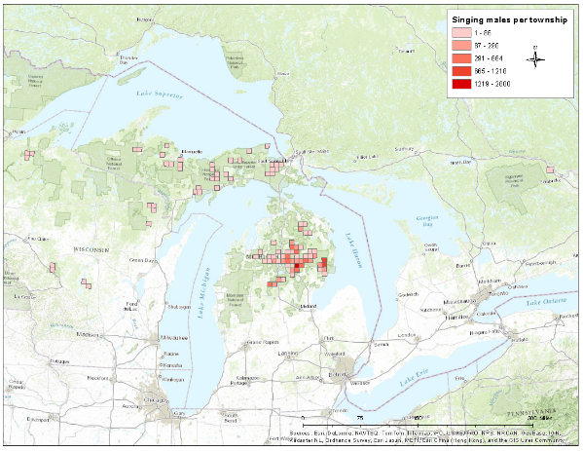
The Kirtland’s Warbler is a federally endangered migratory songbird that may have the most geographically restricted distribution of any mainland landbird in the continental U.S. and Canada. Even with this restricted distribution, protection of this migratory species is complex. Conserving migratory species requires information about threats throughout the range of the species or (its full life cycle). Kirtland’s Warblers breed only in Michigan's northern Lower and Upper Peninsulas, Wisconsin, and Ontario. (Figure 1). Nesting habitat within large tracts of young jack pine forest is both highly specific and disturbance dependent and has probably always been geographically limited. Its ground nests generally are concealed in mixed vegetation of grasses and low shrubs below the living branches of 5- to 20- year old jack pine forests. Kirtland's Warblers are one of more than 200 Neotropical-Nearctic migratory species that nest in North America and winter south of the U.S.
Figure 1. Breeding range of the Kirtland’s Warbler

The winter range of the Kirtland's Warbler was discovered in 1879 when a specimen was collected on Andros Island in the Bahama Islands archipelago. Practically all sightings or collections of wintering Kirtland's Warblers since have been in The Bahamas and in The Turks and Caicos Islands; extralimital winter sightings have been in Hispaniola, Cuba, Jamaica, Bermuda, Florida, and Mexico. Detailed information on the warbler's winter grounds and migration routes is relatively scarce because of its secretive behavior in dense scrub, low population density, and limited research. Additional research, education, and public outreach are crucial to protect the Kirtland’s Warbler, and its’ habitat, along the migration route and during the warbler's six-to-seven month stay in The Bahamas.

Over the past 40 years, state and federal agencies have cooperatively implemented habitat and cowbird management in the breeding range. In response, Kirtland’s Warblers have recovered from fewer than 200 breeding pairs in 1987 to more than 2,300 today. While this is a magnificent endangered species conservation success story, these management strategies only treat the afflictions of habitat loss and nest parasitism, but do not cure them. The Kirtland’s Warbler is considered a “conservation-reliant species” because it cannot survive without human intervention and thus requires consistent financial resources. Therefore, to ensure the survival of the Kirtland’s Warbler, agencies will need to continue habitat and cowbird management into the foreseeable future.

Threats to the successful and continued implementation of the breeding season strategy include: fluctuating timber markets, declining budgets for land management agencies, public pressure to limit the use of current management techniques, and natural events that include drought, fire, and disease and insect outbreaks that have the potential to damage suitable habitat. Threats to implementation of the non-breeding season strategy include: protecting and managing winter habitat, lack of public awareness of the species, rising sea levels and loss of fresh water table, coastal development, and other habitat loss.

In 2016, Kirtland’s Warbler conservation partners ended the Kirtland’s Warbler Recovery Team and formed the Kirtland’s Warbler Conservation Team. The goal of the Kirtland’s Warbler Conservation Team is to ensure the future sustainability of the Kirtland’s Warbler, independent of Endangered Species Act protections. The Kirtland’s Warbler Conservation Team is organized into a Steering Committee and three Sub-Committees: Breeding Range, Non-Breeding Range, and Human Dimensions and Capacity Building. The charge of each Sub-Committee is to implement priority actions as identified by the Kirtland’s Warbler Conservation Team. U.S. Kirtland’s Warbler breeding range partners also drafted The Kirtland’s Warbler Breeding Range Conservation Plan (2015) to replace the 1985 Kirtland’s Warbler Recovery Plan and guide conservation actions into the future.

The Kirtland’s Warbler Alliance, a non-profit organization, was formed in 2013, and has been an active supporter of the Kirtland’s Warbler Recovery Team and, subsequently, the Kirtland’s Warbler Conservation Team, which has replaced the Kirtland’s Warbler Recovery Team. The Alliance’s long-term role focuses on continuing, and expanding, (a) education, outreach, and advocacy efforts in and near Kirtland’s Warbler breeding areas, primarily in Michigan with governmental agencies and non-governmental organizations for habitat protection and management; and (b) building relationships with participating governmental agencies to enhance and ensure their continuing conservation efforts for the Kirtland’s Warbler and its breeding habitat.

The formation of the Kirtland’s Warbler Conservation Team and Kirtland’s Warbler Alliance resulted from successful conservation, and anticipation of potential delisting of the Kirtland’s Warbler. Although recovery goals for the species have been met, continued management (and thus associated costs) will be required to meet the needs of the Kirtland’s Warbler. Securing a combination of private and government funding will be needed to ensure survival of the Kirtland’s Warbler post-delisting. This effort has the potential to be a new model or paradigm for conservation of other conservation reliant endangered or threatened species, which have successfully met recovery goals of the Endangered Species Act.

Implementation Plan

Goal: Sustain a Kirtland’s Warbler population throughout its full life cycle above 1,000 breeding pairs using an adaptive management framework.

Strategy 1: Manage Kirtland’s Warbler breeding habitat and increase the breeding range distribution
Kirtland’s Warblers nest almost exclusively in young, large (minimum of 80 acres) jack pine stands with scattered openings that were historically created by natural regeneration following wildfire. As a consequence of the important work of wildfire suppression programs to ensure human safety and protection of property, Kirtland’s Warbler breeding habitat became rare. Recently, wildfires have contributed a very small proportion of Kirtland’s Warbler breeding habitat. Instead, the majority of Kirtland’s Warbler habitat has been created on public lands by the Michigan Department of Natural Resources (MDNR), U.S. Forest Service (USFS), and U.S. Fish and Wildlife Service (USFWS) through the commercial harvest of mature jack pine forests and replanting of jack pine seedlings in very dense, large plantations.
Actions
- Implement Kirtland’s Warbler management techniques that sustain the Kirtland’s Warbler throughout the breeding range while enhancing other wildlife and economics objectives
  - Annual habitat management on public lands in Michigan breeding grounds – 3,830 acres – to ensure 38,000 acres of suitable Kirtland’s Warbler habitat each year on 220,000 acres of Kirtland’s Warbler Management Areas. Further explore collaboration with timber industry to create new habitat
  - Apply experimental techniques on 25% of Kirtland’s Warbler Management Areas to improve outcomes to Kirtland’s Warblers, other species and natural communities of conservation interest (e.g., endemic, rare, geographically limited, socioeconomically important), and economic interests
    - Modify planting techniques, including tree spacing, planting configuration, and interplanting of red pine to enhance timber value
    - Modify harvest schedule
    - Modify management post-fire
    - Identify, maintain and restore rare natural features and communities within Kirtland’s Warbler Management Areas

- Expand breeding range distribution to ensure there are at least 200 pairs in Michigan’s Upper Peninsula, Wisconsin, Ontario, and possibly Minnesota and Québec
  - Evaluate where the 200 pair goal can best be achieved
- Develop a cost-effective monitoring protocol to assess Kirtland’s Warbler abundance

Strategy 2: Manage cowbird parasitism
The USFWS’s East Lansing Field Office has been responsible for all aspects of the cowbird management program since the program’s inception. However, once the Kirtland’s Warbler is removed from Endangered Species Act protection, the USFWS will no longer operate the cowbird management program. In addition, funding for the cowbird management program will no longer be available through the USFWS’s endangered species program.
In the 2011 Interagency Memorandum of Understanding, the MDNR agreed to take responsibility for the program provided funding was available. The MDNR and USFWS have largely secured funding for cowbird management. To provide for a seamless transition and ensure no break in cowbird management activities, responsibility for operation of this program will shift from the USFWS to state agencies and collaborators.

Other than modifications to the cowbird trap design and an increase in the number of traps, the cowbird management effort was relatively unchanged from 1972 to 2016. In 2016, Dr. Nathan Cooper of the Smithsonian Migratory Bird Center began reducing the number of cowbird traps and found that nest parasitism rates remained below 1%. His data on nest success rates and cowbird populations at Kirtland’s Warbler sites, following reduced and eventually no cowbird control, are now available to help inform managers about potential modifications to the cowbird management program. Results from this work suggest the possibility of a reduction in scale or scope, or even eventual elimination of the cowbird management program. However, long-term monitoring of the cowbird population and the parasitism rate will be necessary to ensure that if and when cowbirds return to the landscape, managers will be the first to know and can respond accordingly.

Detailed action plans are listed in the Kirtland’s Warbler Conservation Team Breeding Range Subcommittee Work Plan.

Actions
- Monitor cowbird populations and nest parasitism to ensure cowbird parasitism rates are low enough to maintain the population goal of the Kirtland’s Warbler
  - Ensure there are adequate funds currently and post-delisting to manage cowbirds as needed
    - Continue building an income-generating fund to support cowbird management, monitoring and research efforts
- Fill information gaps
  - Determine the maximum sustainable rate of parasitism in Kirtland’s Warblers via population modeling
  - Determine how cowbird abundance and parasitism rate are related
  - Determine the most cost-efficient approach to monitoring to ensure that cost-savings are realized after trap reduction or elimination

Strategy 3: Determine where and when the Kirtland’s Warbler may be threatened or limited during the non-breeding season and implement actions to abate threats
The Kirtland’s Warbler winters in dense coppice (hardwood) scrub, primarily on the central Bahamas islands of Eleuthera, San Salvador, Cat, and Long Islands. The Kirtland’s Warbler migration route extends from The Bahamas north through Florida to the breeding grounds and south along a more easterly route through North and South Carolina to The Bahamas. The winter ecology of the Kirtland’s Warbler has been intensively studied since 2002 and various aspects of migration and connectivity have been studied since 2003.
Both natural (e.g., hurricanes, fire) and anthropogenic (e.g., farming, other clearing) activities create winter habitat. Late season winter drought negatively affects condition of birds and also reduces number of young raised on the breeding grounds following drought, possibly in combination with conditions during migration. It is incompletely known how habitat availability and quality during winter and migration, and interactions between winter and migration, affect survivorship of Kirtland’s Warbler.
Conservation efforts need to focus on ensuring there is sufficient high-quality habitat and building sufficient local awareness of the Kirtland’s Warbler during the non-breeding season so that there are enough resources devoted to land protection and management to support the population goal. Building conservation and research programs that facilitate exchange of information and funding between those working on the nonbreeding seasons and breeding seasons will be essential to ensure population goals are maintained, including engagement of landowners and land managers, especially on the central Bahamas.
Detailed action plans are listed in the Kirtland’s Warbler Conservation Team Non-breeding Range Subcommittee Work Plan.
Actions
- Protect and manage overwintering habitat in The Bahamas
  - Maintain rights-of-way management to sustain Kirtland’s Warbler habitat under power lines
  - Facilitate habitat management on goat farms, habitat frequently used by wintering Kirtland’s Warblers
  - Initiate land protection and management at wintering sites on Eleuthera, Cat, Long, and San Salvador Islands and at migration stopover sites.
- Identify, protect, and manage stopover sites along migration route
- Support long-term commitment to Kirtland’s Warbler conservation efforts through sustainable partnerships, especially with Bahamian organizations
  - Work with Bahamas National Trust and other non-governmental organizations with environmental focus on Eleuthera, Cat, Long, and San Salvador islands
    - Meet with island administrators/public to increase awareness and needs of Kirtland’s Warbler
    - Provide educational materials to local schools that links breeding and non-breeding areas, including Kirtland’s Warbler calendar
    - Fund training of bird/ecotourism guides
    - Fund avian ecologist position in The Bahamas
  - Complete Kirtland’s Warbler Non-breeding conservation/management plans
- Fill information gaps
  - Describe carry-over effects comprehensively, including context of projected climate change
  - Map distribution of Kirtland’s Warbler winter habitat in central Bahamas (Eleuthera, Cat, Long, & San Salvador) to assess adequacy of winter habitat availability and evaluate its potential future fate including under different climate change scenarios
  - Determine what management activities are needed, and where, to ensure sufficient habitat during winter for 4,100 adult and first year Kirtland’s Warblers
  - Map important stopover sites
  - Determine what protection and management activities are needed, and where, to ensure sufficient habitat during migration for 4,100 adult and first year Kirtland’s Warblers

Strategy 4: Human Dimensions (outreach, socioeconomics)
Effective outreach must increase public awareness and understanding of Kirtland’s Warblers conservation needs throughout the bird’s life cycle. Messages must be crafted. Effective delivery techniques must be designed and evaluated. New partnerships must be created. Conservation programs that directly and indirectly benefit Kirtland’s Warblers should engage private landowners, governmental entities, economic and community development entities, philanthropic organizations; and marketing, communication, and human behavior experts. Successful connections with these individuals and organizations will result in new revenue streams and greater public support of Kirtland’s Warbler conservation.

Additional detailed action plans are listed in the Kirtland’s Warbler Conservation Team Human Dimensions and Capacity Building Subcommittee Work Plan.

Actions
- Improve the ability of the Kirtland’s Warbler Conservation Team to investigate how humans value, use, and depend on the Kirtland’s Warbler
  - Improve knowledge of needs, preferences, and values of stakeholder groups within Kirtland’s Warbler landscapes and its associated habitats
  - Conduct “human dimensions” threats assessment across geographies of Kirtland’s Warbler and identify strategies for stronger community connection
  - Map communication pathways to show linkages and influence among stakeholders
- Increase awareness of Kirtland’s Warbler ecology, conservation needs and management practices among community members
  - Identify all possible audiences and determine process for assessing, selecting and revaluating priorities
  - Help stakeholders explore Kirtland’s Warbler habitat to understand management issues
  - Develop clear communications strategy, with specific partner roles, key messages, targets, etc.
  - Identify creative ways to engage and involve economic, business, and community leaders, service organizations, and city planners (collaborative learning opportunities)
- Increase citizen awareness of conservation efforts to engage public
  - Define with partner groups what “meaningful public engagement” looks like with regard to management activities (facilitated visioning sessions)
  - Provide training resources and talking points to community stakeholders and land managers on how to engage on this topic/Kirtland’s Warbler conservation/broad outcome for conservation and communities
  - Maintain and expand volunteer opportunities
    - Maintain annual jack pine planting day
    - Encourage partners to hold volunteer events throughout Kirtland’s Warbler range
    - Maintain opportunities for public participation in monitoring programs
- Increase use of Kirtland’s Warbler information in meeting local school and curricula goals and requirements across the full life cycle
- Increase human dimension skillsets within Kirtland’s Warbler Conservation Team

Strategy 5: Organizational coordination and capacity building
Capacity must be built – people, money, and partnerships – to sustain important conservation programs over time. This work depends upon open and continued communications among the agencies involved and between them and the public. Issues must be identified and understood.
Actions:
- Increase capacity of Kirtland’s Warbler Conservation Team to implement human dimensions and capacity building work
  - Develop governance and decision making structure for Conservation Team
  - Establish method for administratively and financially supporting work of Conservation Team
  - Map communication across fully functional Conservation Team and develop tools to increase efficiency and collaborative working abilities that support expanding partnerships and goals of the conservation effort
  - Hire a paid, part-time coordinator for the Conservation Team
  - Expand online and other external communications and coordinate communications across Conservation Team and Alliance
- Support establishment of cross-program priorities and facilitate identification of a collaborative funding strategy
  - Establish prioritization process across all programs and needs
  - Identify long-term funding framework and decision making process that all partners agree on and support
  - Facilitate development of strategies for partners to understand how to identify and secure short-term and endowment funding opportunities to support the broad range of programs and needs
  - Review and update Conservation Business Plan as needed

Strategy 6: Research and Monitoring
Research and monitoring needs are embedded in each of the strategies. The highest priority research and monitoring needs are noted in this business plan. Other research and monitoring needs are described in each of the Kirtland’s Warbler Conservation Team work plans: Breeding range, Non-breeding range, and Human dimensions and capacity building.

Actions
- See Strategies 1-4.

Conservation Outcomes

As a result of our investments, we anticipate achieving our goal of maintaining a minimum of 1,000 breeding pairs for the foreseeable future through the following conservation outcomes:
- Establish a program that ensures an average of 3,830 acres of new breeding habitat are created annually and ensures there is a minimum of 38,000 acres of suitable breeding habitat in any given year.
- Ensure there are at least 37,500 acres of high-quality overwintering habitat distributed across at least the following 4 Bahamian islands: Eleuthera, San Salvador, Cat, and Long Islands. (Note: high degree of uncertainty about this estimate; current estimates of habitat are unknown because Kirtland’s Warbler home ranges may vary by island, within winter, and by sex and age)
- Manage and monitor nest parasitism by cowbirds to ensure productivity of at least 3.5 fledged young/Kirtland’s Warbler pair
- Create information and education efforts to build political support that will lead to sufficient funding and commitment for habitat management
- Complete an economic impact report detailing the economic return of conservation programs to communities for Kirtland’s Warbler
- Establish a long-term fund to sustain priority conservation efforts and operational costs post-delisting to (1) compensate for loss of endangered species funding, (2) expand funding for other priority activities for the Kirtland’s Warbler throughout its range, and (3) achieve related landscape objectives, including benefits to other species
- Work with conservationists with other endangered and threatened species to adopt this new paradigm for delisting conservation reliant species when appropriate

Funding Needs/Budget

The estimated funding needs (as of March 2019) to implement actions to sustain at least 1,000 breeding pairs of Kirtland’s Warblers are outlined in Table 1. Based on anticipated annual (recurring) funding needs that are not met by current funding (“Projected Expenditures from non-DNR Endowment”), an endowment fund, now in its initial stages of development, will be need to be created by ongoing fund raising to generate income to meet this shortfall. In addition, fund raising for short-term projects will be needed to supplement Kirtland’s Warbler revenue generated from the endowment fund.

Table 1. Annual Cost Estimates for Required Activities:

Activity | Projected Annual Expenditures | Projected Short-term Expenditures | Projected  Expenditures from non-DNR Endowment
Breeding Habitats | 1,941,000 | 1,433,500 | 131,000
Annual Habitat Regeneration | 1,700,000 | 0 | 0
Annual Monitoring | 40,000 | 0 | 40,000
Annual Cowbird Control | 100,000 | 0 | 0
Research (1st 10 years) | 0 | 1,370,000
Information and Education | 101,000 | 63,500 | 91,000
Wintering Habitats | 155,000 | 495,000 | 155,000
Habitat Protection/Regeneration | 11,000 | 15,000 | 11,000
Research (1st 10 years) |  | 456,000
Information and Education | 144,000 | 24,000 | 144,000
Coordination of Conservation | 90,500 | 33,000 | 90,500
TOTAL | 2,186,500 | 1,961,500 | 376,500

Note: Annual costs to be covered by income from new endowments (excludes research and short-term costs and costs covered by DNR trust fund): $376,500.

Evaluation and Monitoring

We will evaluate the success of the Kirtland’s Warbler conservation efforts by the following strategies, metrics, and goals given that the ultimate goal is to ensure a minimum of 1,000 breeding pairs of Kirtland’s Warblers for the foreseeable future.

Table 2. Core metrics for measuring progress on program strategies.

Strategy | Metric | Goal
Habitat management in the breeding grounds | Acres restored | Number of available acres at any one time is sufficient for at least 1000 breeding pairs (38,000 acres).
Expand breeding range in the Upper Peninsula, Wisconsin and Ontario, and possibly in Québec and to Minnesota | Number of breeding pairs | At least 200 pairs of KW population breeding outside Michigan’s northern lower peninsula.
Habitat management at overwintering sites | Acres restored/maintained | Number of available acres (on Eleuthera, San Salvador, Long Island, Cat Island) at beginning of winter is sufficient for at least 4,100 KWs.
Reduce cowbird parasitism | Per-cent of Kirtland’s Warbler nests parasitized | Rate of cowbird parasitism for sustainable population unknown; modeling and additional monitoring needed
Increase outreach and coordination | Sufficient funding and commitment to support habitat management and fill information gaps that complements agency and academic commitments | Partners are self-sustaining, politically supported and contributing XX% of KW management/research costs range wide
Establish and endowment fund that supports annual conservation and human dimension needs | Annual investment income sufficient to meet annual costs identified in Table 1 | $7.52 million

Partner Organizations

It will require many partners to meet conservation goals for the Kirtland’s Warblers. A list of partners currently serving on the Kirtland’s Warbler Conservation Team or Kirtland’s Warbler Alliance appears below; other partners, many of whom are noted in the work plans, are engaged with representatives of these groups. This list will be modified over time as actions are implemented.

American Bird Conservancy
Bahamas National Trust
California University of Pennsylvania
Canadian Wildlife Service
Detroit Audubon Society
Detroit Zoological Society
Herbert H. and Grace A. Dow Foundation
Huron Pines
Michigan Department of Natural Resources (current staff and retired)
Michigan State University
Migratory Bird Center, Smithsonian Conservation Biology Institute
National Audubon Society
Harry A. and Margaret D. Towsley Foundation
U.S. Fish and Wildlife Service
U.S. Forest Service – Chequamegon-Nicolet, Huron-Manistee, and Ottawa National Forests
U.S. Forest Service – International Institute of Tropical Forestry
Wayne State University
Wisconsin Department of Natural Resources

